HIGH HEELS
  - Element of Culture
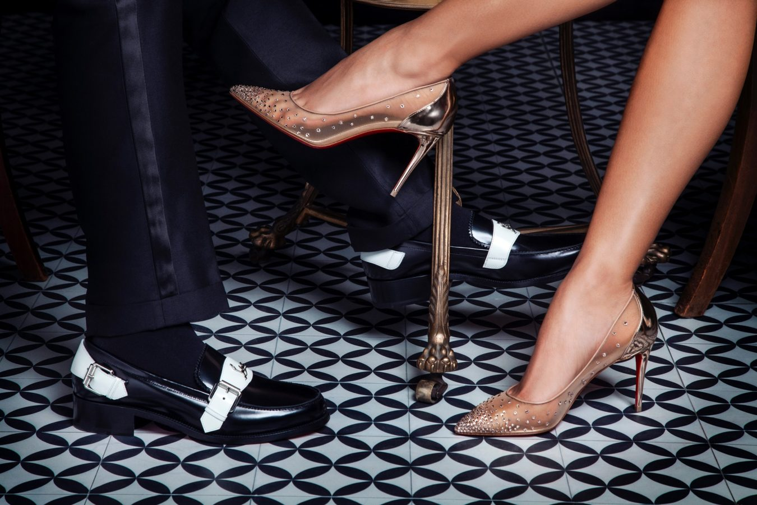
Abbie smith

1.0 Introduction | 1
2.0 Dispersal of High Heels | 2
3.0 Diffusion of High Heels | 3
3.1 Factor One – Advancements in transport telecommunications | 4
3.2 Factor Two – Role played by transnational institutions | 5
4.0 Case Studies | 6
4.1 Case Study One – Resisting High Heels | 6
4.2 Case Study Two – Adapting High Heels | 7
5.0 Implications of the changes in the Nature and Spatial Distribution of High Heels | 8
6.0 Likely future changes in the nature and spatial distribution of High Heels | 9
7.0 Bibliography | 10

Table of
Contents

1.0 Introduction
Culture is an umbrella term which encompasses the social behavior and norms found in human societies, as well as knowledge, beliefs, laws, customs, capabilities and habits of the individuals in these groups. The element of culture covered in this report is fashion and more specifically high heels. This report will cover the dispersal and diffusion of high heels. The roles played by advancements in transport and telecommunications and transnational institutions on high heel diffusion and dispersal. Two case studies looking at how different locations have either embraced, resisted, or adapted high heels. The changes in spatial distribution and nature of high heels and the likely future changes in these areas.

Dispersal of high heels
High heels were first noticeably and commonly used in the 10th century. This is when Persian (modern day Iran) soldiers were the first to discover that heeled shoes helped their feet stay in their stirrups and gave them the stability the needed to shoot their bow and arrows (2.0.1). By the 17th century it was normal for Persian riders to wear one-inch heels on and off their horses. Heeled shoes developed to symbolise money and power since having horses was a symbol of affluence. At the end of the 17th century, Persian Shah sent a delegation of soldiers to create relations with foreign leaders in places such as Russia, Germany, and Spain. This led to European aristocrats adopting heels as a symbol of virility and military prowess. Under Louis XIV’s rule, the higher and redder the heel, the more powerful the wearer. In 1670, he passed an edict that stated only nobility could wear heels. In the 18th century heels became more of a woman’s shoe, men stopped wearing heels around 1730 as a reaction against their perceived feminisation. Then the French revolution put an end to the usage of male heels, however, some lifestyles still accepted the wearing of male heels, cowboy boots for example. In more recent times pop culture and musicians were able to popularise the heel. The Beatles helped popularise the Cuban heel in the 1960’s and 1970’s. David Bowie was known for pushing the boundaries of gendered fashion and he would wear a manner of heels. Mötley Crüe also wore the Cuban heel and helped add to the heel being in relation to a rough, rocker aesthetic. 2.0.2 shows this information in a timeline format.

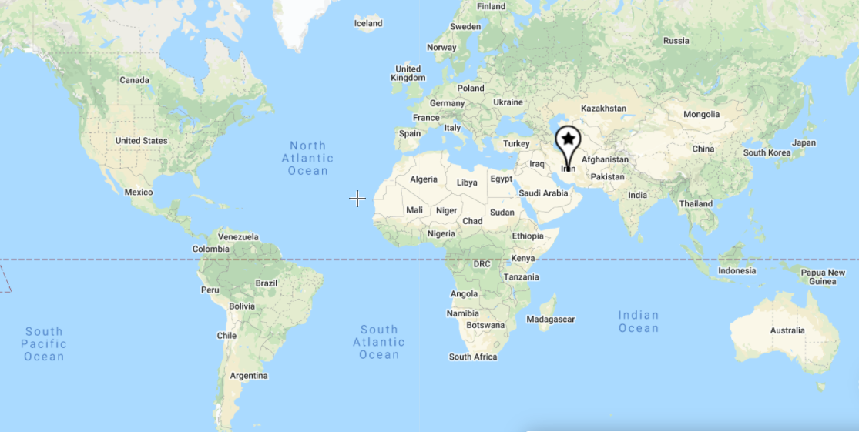

2.0.1- Map showing high heels origin point.
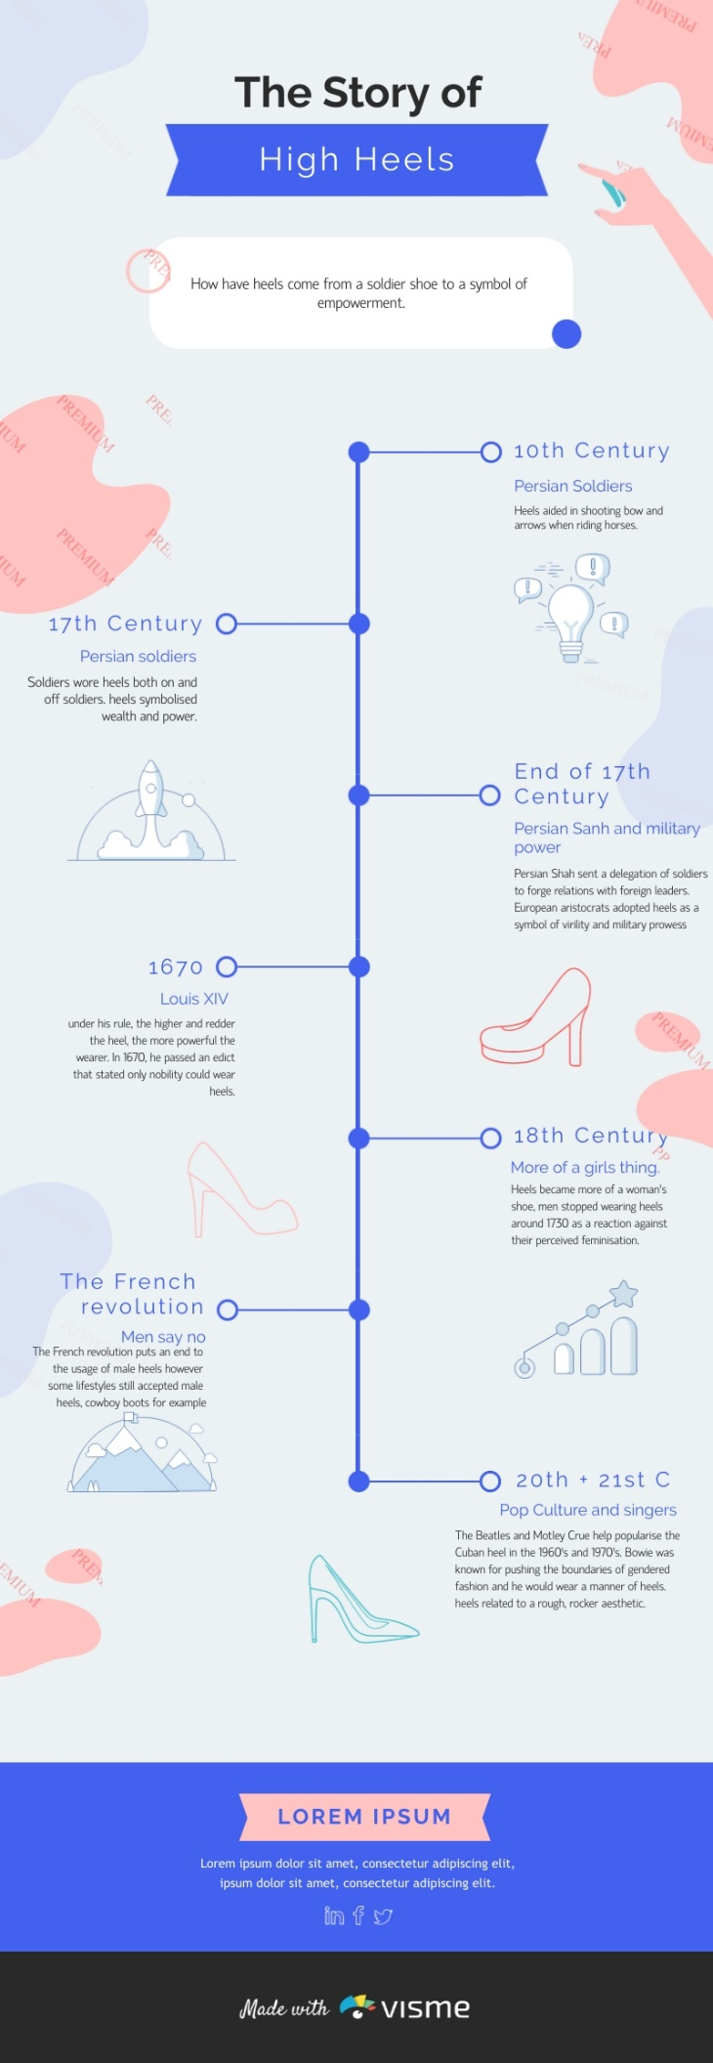
2.0.2- Timeline of the history of high heels.

3.0 diffusion of high heels
Diffusion is the transfer or dispersal of cultural elements from one group of people to other groups of people. The diffusion of high heels was from the origin point of Persia or modern-day Iraq to Europe and then to the rest of the world. This diffusion was a result of high heels being seen as a symbol of military power and wealth.
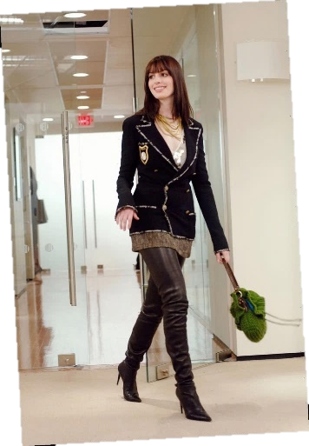
3.1 factor one – Advancements in transport telecommunications
Containerisation, steamships, aeroplanes, and trains are examples of transportation developments that have aided in the spread of high heels. Accessibility between locations has improved, and travel time and cost have decreased because of these developments. Sailing used to take months to go from point A to point B before steamships came along and cut the journey time in half. Then, when aeroplanes were invented, it was shortened to days.
3.1.1
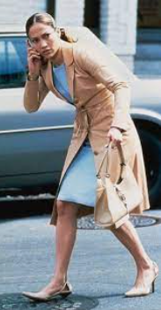
The cost of transporting commodities is decreasing as planes become larger and more fuel efficient. Freight costs have been decreased thanks to advancements in ship, truck, and train design. Containerization makes it simple to load and unload huge amounts of cargo on and off ships.
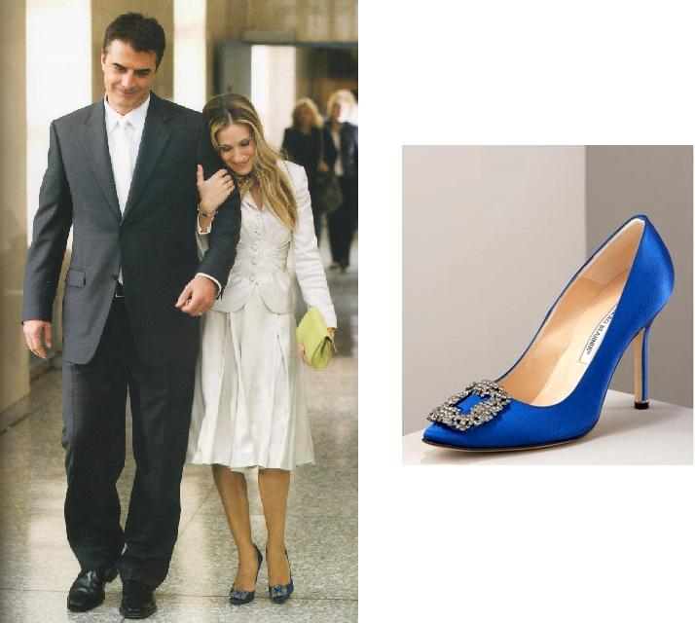
The media, internet shopping, and E-parcel are examples of telecommunications advancements that have contributed to high heel dispersion. The internet enables for the distribution of a wider range of information over longer distances, such as shopping online. Money can be transferred instantly via the internet using electronic transfers. Global citizens in industrialised countries can shop for fashion from around the world on the internet, have it shipped to them, and track it. People can buy something using an app or a website and have it delivered to them within 24 hours, which is known as e-tailing. People may track their delivery online with Australia Post's parcel post.
3.1.2
Fashion TV shows help in the diffusion of high heels. Fashion shows are televised to a large audience all over the world, and they can promote new fashion trends and concepts. Examples of shows include Queer eye and Project Runway. Hollywood films, particularly those concerning fashion, have always been opinion leaders in the business, influencing communication, distribution, commentary, and design. Examples include Devil wears Prada with Chanel high heeled boots worn by Anne Hathaway (3.1.1). The Wedding Planner with nude Chanel worn by Jennifer Lopez (3.1.2). Finally, Sex and the city with Manolo Blahnik Hangisi worn by Carrie Bradshaw (3.1.3).
3.1.3
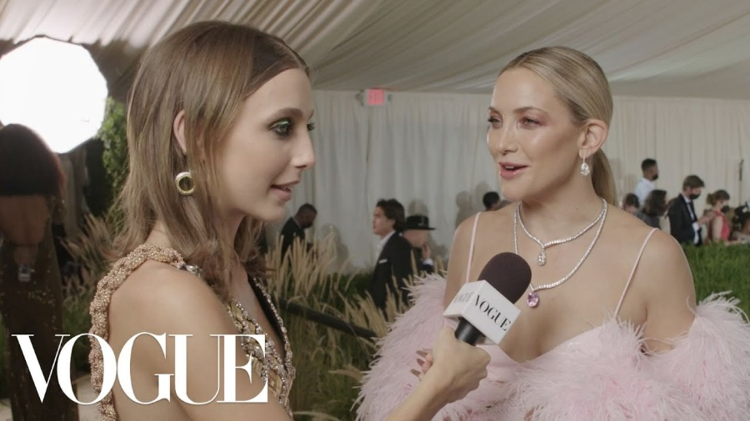
The new modern media composed of vloggers and influencers help with the diffusion through a process known as democratisation. Democratisation occurs when everyone, regardless of their location, has access to fashion information and purchasing power. Social media's vloggers and influencers achieve this by showing behind-the-scenes footage from major fashion events like New York fashion week and the Met Gala. At the 2021 Met Gala Vogue put out a YouTube series of influencer Emma Chamberlain interviewing famous celebrities and questioning them about their outfits (3.1.4).
3.1.4- Emma Chamberlain interviewing actress Kate Hudson.

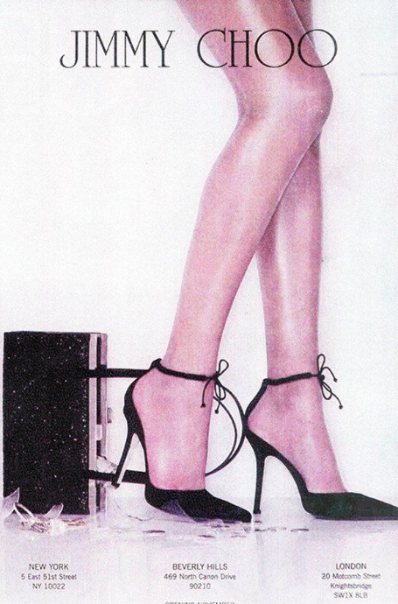
3.2 factor two – Role played by transnational corporations
A Transnational Corporation operates in more than one country and with its operations has enabled people from all around the world to purchase high heels and thus facilitated in the diffusion. Jimmy Choo is a leading global luxury brand with its sole product being high heels. The company was founded in the early 1990s by a shoemaker named Jimmy Choo, who was in London's East End.
Choo opened his first shop in Hackney in 1986. It didn't take long for Choo's reputation to build. Within two years of opening his shop, Choo's shoes were featured in an eight-page spread in Vogue magazine. 3.2.1 shows an advert for Choo shoes in 1998 in Vogue magazine. Vogue has a large global footprint with 22.5 million monthly viewers of the magazine and its content. Soon, Choo became the darling of the celebrity world, in particular Princess Diana, who dressed in Choo's footwear seemingly everywhere she went. But it was his relationship with Vogue that would prove to be instrumental in the rise of the Jimmy Choo brand. Despite the rise of his popularity, Choo was still a small operation, producing just 20 handmade pairs of shoes a week. But Tamara Mellon, an accessories editor at Vogue, who often hired Choo to make shoes for fashion shoots, sensed a larger market for Choo's creations. She approached the shoemaker about partnering to create a line of ready-to-wear footwear. Together, Choo and Mellon quickly grew the business, keeping the focus on creating high-end footwear, but no longer relying on the idea that every single pair had to be made by Choo himself. They contracted with Italian factories and opened their first boutique shop in London.
3.2.1- 1998 advert for Choo in Vogue.

The Jimmy Choo Company was founded in 1996. The cut, design, and craftsmanship left a lasting impression on clients, and the first collection was an enormous success. A pioneer in dressing celebrities, Jimmy Choo was among the first to bring shoes and handbags to Hollywood where displaying his work on the red carpet proved to be ideal for the brand. The brand's popularity as a celebrity favourite aided in its rapid growth. The striking and powerful advertising, which featured gorgeous yet strong women in tall heels and was taken by some of the world's most famous fashion photographers, further established the brand. The company's strategy has included retail development. Jimmy Choo's first store opened on Motcomb Street in London in 1996, adding to its distribution in some of the biggest and most popular stores. In 1998 the company expanded to America, opening two stores in New York City and Beverly Hills. Jimmy Choo's international development continued with stores opening on Sloane Street and Bond Street in London, Avenue Montaigne in Paris, Avenue in New York, Rodeo Drive in Beverly Hills, and Ginza in Tokyo. Jimmy Choo has a global store network encompassing more than 200 stores and is present in the most prestigious department and specialty stores worldwide.

4.0 CASE STUDIES
The following sections look at the resistance of high heels in Japan because of female workers being required to wear them, which has evidently been detrimental to their health. Also, the embracement of high heels has been noticeable in the activity of Drag Queens as they are used to enhance their costumes and to make them seem more feminine.

4.1 Case Study One – resisting high heels
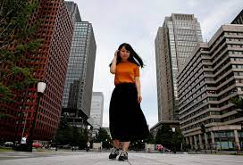
The resistance to high heels in Japan reflects the shifting reputation of Western products in Japan. The 2019 #KuToo rebellion is against high heels, which are a symbol of erotic desire and at the same time female empowerment worldwide.
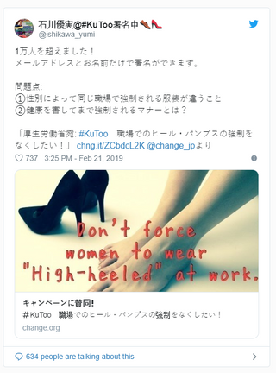
The first time Yumi Ishikawa, the face of the #KuToo movement (4.1.1), took to social media to call for an end to the requirement that female workers must wear high heels, her tweet was shared nearly 30,000 times. “Why do we have to work while hurting our feet?”, she asks, pointing out the gender inequality, “Whereas men can wear flat shoes.” (4.1.2). Many businesses in Japan require women to wear heels between five and seven centimetres. Ishikawa collected 18,000 signatures for a petition on women not being forced to wear high heels in the workplace and presented it to Ministry of Health, Labour and Welfare.
4.1.1- Ishikawa wearing sneakers.
The parliamentary committee was not in favour of acting on the petition. Major members voiced a belief that at work women should be dressed appropriately. Prominent cell phone service suppliers, Softbank, and NTT DoCoMo have eased dress requirements since #KuToo became widespread, allowing women to wear shoes without high heels.
In June 2019, Ishikawa hosted an event in Tokyo where men tried on high-heeled shoes and attempted to walk in them, allowing them to feel the difficulty and pain firsthand.
She described Japan as viewing the movement in terms of health concerns rather than discrimination based on gender. The #KuToo movement’s progression remains slow due to various obstacles solidified by long-standing views on gender roles in Japan. Japanese views on gender roles remain traditional.
4.1.2- Ishikawa’s original tweet that sparked the movement
Campaigners have compared the high-heel policies to the ancient Chinese practice of foot binding. Foot binding was a process where young girls’ feet were broken and altered by being bound in scarves to prevent them from growing.
The rule of the use of heels being mandatory in Japan displays that gender and dress code take precedence over people of different genders doing the same work. Also, that wearing heels is considered appropriate and polite, but manners shouldn’t prevail over efficiency and women’s health. The health problems of regularly wearing high heels include lower back, hip, knee issues, and osteoarthritis.
Japan is not the only country that has issues with women dress codes in work environments. Both British Columbia and the Philippines passed laws banning companies from forcing women to wear high heels in 2017. In 2016, Nicola Thorp sparked outrage throughout England, when she was sent home from work without pay, and later fired, for not wearing heels.

4.2 Case Study Two – embracing high heels
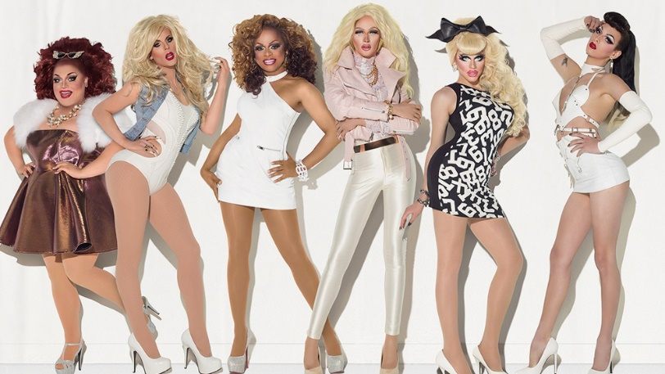
An example of the embracement of high heels is in the self-expressive activity of drag queens. A drag queen is a person, generally a man, who imitates and exaggerates feminine features and roles for entertainment reasons by wearing clothing, high heels, and cosmetics. Drag queens, on the other hand, prefer to opt for a more exaggerated look, with more makeup than an average lady. With their appearance, a drag queen may strive for a specific style, celebrity impersonation, or message. Drag queens' most crucial accessories are hair, make-up, outfits, and heels (4.2.1). People engage in drag for a variety of purposes, including self-expression and public performance. Drag is notorious for shattering gender stereotypes and can be considered gender bending. When a person dresses and acts like a member of the opposing sex, this is known as gender bending. Drag has become a celebrated and significant part of modern LGBTIQQ culture.
4.2.1- Drag queens in their costumes with makeup and high heels.
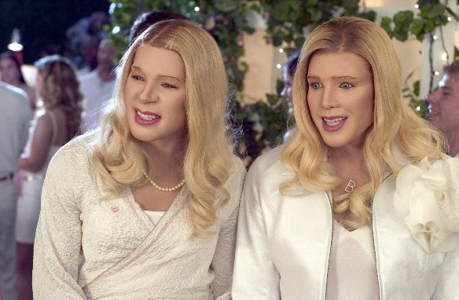
Drag queens display their talent in drag shows. A drag show is a style of entertainment in which artists in drag perform a variety of songs, monologues, or acts in front of an audience. Lip-syncing, live singing, and dancing are all common features of drag shows. They can be found at events such as gay pride parades and drag pageants, as well as cabarets and clubs. Several "International Drag Day" celebrations have been established to promote drag events over the years. In Hollywood, famous movies that have incorporated drag queens or qualities of drag queens include: The Rose (1979) starring Bette Midler. Mrs. Doubtfire (1993) starring Robin Williams. Flawless (1999) starring Philip Seymour Hoffman and Robert De Niro. White Chicks (2004) starring Shawn Wayans and Marlon Wayans (4.2.2) and Hurricane Bianca (2016) with appearances by RuPaul.
4.2.2- Drag in the 2004 movie “White Chicks”.
RuPaul, is a world-renowned American drag queen (4.2.3). He achieved international fame as a drag queen with the release of his single, "Supermodel (You better work)”. In 1994, he became a spokesperson for MAC Cosmetics, raising money for the Mac AIDS Fund and becoming the first drag queen to land a major cosmetics campaign.
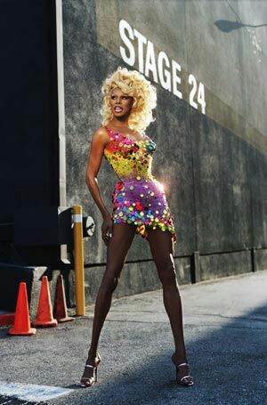
RuPaul started creating RuPaul's Drag Race, a reality television game program, in mid-2008. He has been the producer and host of the reality competition series since 2009, for which he has won eight Primetime Emmy Awards. The show's concept is that many drag queens compete to be named "America's next drag superstar" by RuPaul and a panel of judges. RuPaul's televised drag competition, is the most popular program on the Logo television network. In the United States, RuPaul's Drag Race has aired thirteen seasons to date. The show has been a global hit, with six international formats currently in production.
In 2016, the show won a Primetime Emmy Award for Outstanding Host for a Reality or Reality-Competition Program. He was named in the annual Time 100 list of the world's most powerful people in 2017. He was named "easily the world's most famous" drag queen by Fortune in 2019. The show made history in 2018 by being the first to win both a Primetime Emmy Award for Outstanding Reality-Competition Program and a Primetime Emmy Award for Outstanding Host for a Reality or Reality-Competition Program in the same year. RuPaul, who was not in drag at the time, became the first drag queen to host Saturday Night Live in 2020. RuPaul was awarded a star on the Hollywood Walk of Fame, making him the first ever drag queen to do so.
4.2.3- RuPaul in drag.

5.0 Changes in the Nature and Spatial Distribution of high heels
 | Positive Implications | Negative Implications
Nature | - The nature of fashion is that a style or item is innovated.  - Fast fashion has had the greatest impact on the spatial distribution and changing nature of fashion.  - Fast fashion is cheap and keeps up to date with all the new and emerging trends. | - Fast fashion has been detrimental to the local fashion businesses.  - They are competing against large corporations with lower prices and a larger range and online shopping for fast fashion.  - 85% of fashion bought in Australia ends up in landfills.  - Wear it once or twice and discard it when it goes out of fashion or breaks because of poor quality.  - Fast fashion is an environmental disaster in both manufacturing and disposal.
Spatial distribution | - The spatial distribution of fashion describes where an innovation is created, manufactured, and purchased and how these places relate.  - Fast fashion has moved quickly from major catwalks to the consumer’s hand all over the world.  - The less developed countries rely on the manufacturing industry to be able to sustain their large population. | - Fast fashion starts off with developed countries producing the expensive raw material of cotton.  - Less developed countries supply cheap labour and materials to make fashion.  - This provides a large profit margin.  - However, less developed countries have poor working conditions and salaries.

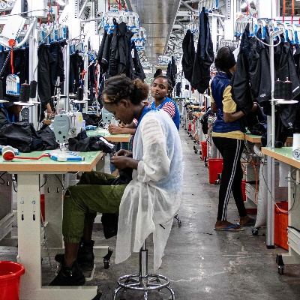
5.0.1- The truth behind fast fashion.
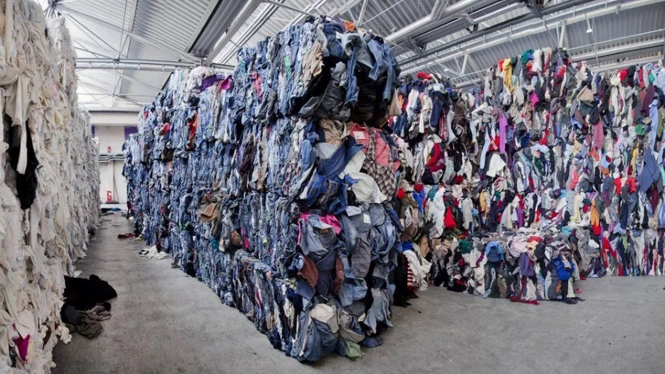

6.0 Likely future changes in the nature and spatial distribution of high heels
 | Nature | Spatial distribution
Future Trends | - 3D printing is only just being introduced but it is predicted to be quite large in the future.  - This will enable consumers to print their own items if they have a printer which will impact the spatial distribution.  - They can print out a design in their own choice fabric and in their measurements.  - 3D printing is as revolutionary as the sewing machine.  - In the production phase there will be less material waste.  - Early adopters are using it to make jewelry, footwear, and eyewear.  - As more attention is being drawn to the negative effects of fast fashion consumers will be looking for alternatives.  - Alternatives to fast fashion include handmade, conscious designers, ethical brands, clothing rental awareness campaigns, donating and clothes swapping.  - Companies try to avoid responsibility for the fashion factories making their high heels by not directly owning the factory.  - To hold companies more accountable they will have to own the factories.  - Virtual reality and augmented reality.  - Virtual Reality creates a 3D environment and Augmented Reality creates an overlay of data to enhance consumer’s experience.  - Virtual Reality allows for people to try clothes on without doing it physically.  - Augmented Reality allows for people to check for sales of clothing items, their company’s sustainability and work environment.  - They are used in the clothing design process.  - Useful when manufacturers and designers are international or remote. | - Ethical Clothing Australia ensures that local textiles footwear and clothing comply with their supply chains and all legal obligations in the industry.  - Sustainable Apparel Coalition is an international collaboration of brands, manufacturer’s, government, and non-government organisations.  - Working to reduce the social and environmental impact of the fashion industry.  - Developed the HIGG index which provides tools to measure clothing company’s sustainability levels.  - The index encourages changes to a company’s sustainability levels, workers wellbeing, workers communities, and environment.  - Consumers are becoming more aware of the environmental effect of fashion; they will research a company’s sustainability performance before they purchase any high heels.  - If a person buys an item from a company with low sustainability and worker environments, they are indirectly supporting these conditions.  - Modern fashion apps allow for instant gratification and the awareness of clothes high heel sales and improves accessibility to heels.  - Consumers can rate fashion choices, environmentally friendly brands, save money through sale alerts and make purchases through the app.
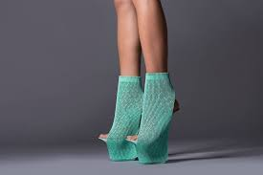
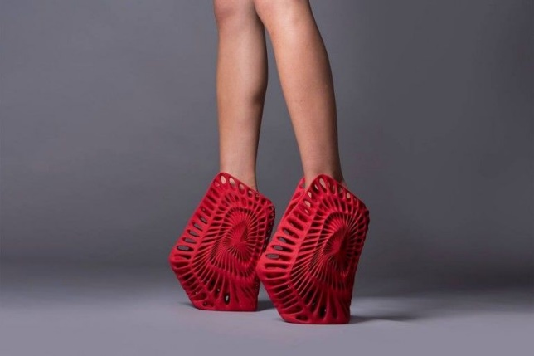

6.0.1- 3D printed shoes.
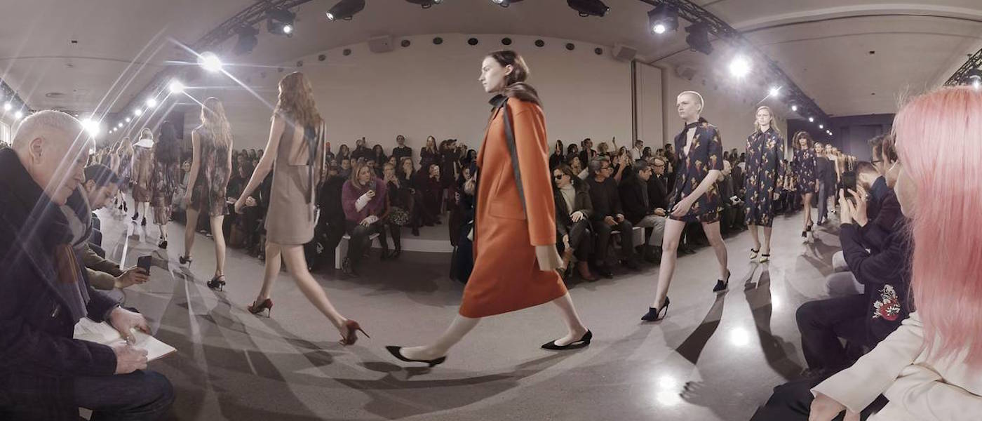
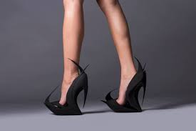
- Virtual Reality is quite beneficial towards the fashion industry currently during the COVID-19 pandemic. Because of restrictions in place fashion shows can take place and guests can tune in and view the show at home to prevent outbreaks (6.0.2).
6.0.2- Virtual Reality fashion show.
VR

7.0 Bibliography
- Bass-Krueger, M. (n.d.). The High-Life: A History of Men in Heels. Google Arts & Culture. Retrieved August 2, 2021, from https://artsandculture.google.com/story/the-high-life-a-history-of-men-in-heels/iQJCgMgwSKV5Kw
- Biography.com Editors. (2020, August 19). Jimmy Choo. Biography. https://www.biography.com/fashion-designer/jimmy-choo
- Deron, B. (2018, December 15). The History of Drag Queens and The Evolution of Drag. All That’s Interesting. https://allthatsinteresting.com/history-of-drag-queens
- Griffin, A. (2018). WA ATAR Geography. Geographical Association of Western Australia Incorporated.
- Jimmy Choo. (n.d.). Jimmy Choo | About Us | Company Profile. Retrieved August 28, 2021, from https://row.jimmychoo.com/en/customer-service/about-us.html
- Reisel, M. (2021, August 27). The Japanese Rebellion against the Western High-Heels: When Feet Represent the Head. Linkedin. https://www.linkedin.com/pulse/japanese-rebellion-against-western-high-heels-when-feet-mary-reisel
- Rich, M. (2020, January 15). The Japanese Rebel Who’s Fighting the Tyranny of High Heels. The New York Times. https://www.nytimes.com/2019/12/10/world/asia/japan-kutoo-high-heels.html
- TheProducer. (2020, July 14). Top 5 Most Iconic High Heel Moments in Movie History. Tmc.Io - Watch Movies with Friends. https://tmc.io/top-5-most-iconic-high-heel-moments-in-movie-history/
- Wikipedia contributors. (2021a, August 19). KuToo movement. Wikipedia. https://en.wikipedia.org/wiki/KuToo_movement
- Wikipedia contributors. (2021b, September 17). Drag queen. Wikipedia. https://en.wikipedia.org/wiki/Drag_queen
- Wikipedia contributors. (2021c, September 17). RuPaul. Wikipedia. https://en.wikipedia.org/wiki/RuPaul

Photo Bibliography
Front cover photo-
3.1.1- https://www.elle.com/fashion/news/a37442/devil-wears-prada-facts/
3.1.2- https://www.reddit.com/r/filmfashion/comments/eyzf4r/classic_late_90searly_2000s_minimalist_styling/
3.1.3-https://www.enstock4g.top/products.aspx?cname=sex+and+the+city+wedding+shoes&cid=35
3.1.4- https://www.youtube.com/watch?v=A8_p4nbtksg
3.2.1- https://www.pinterest.com.au/pin/797418677747203191/
4.1.1- https://www.nytimes.com/2019/12/10/world/asia/japan-kutoo-high-heels.html
4.1.2- https://www.hustle4diversity.com/post/we-wear-heels-when-we-want-to-not-when-we-re-told-to-says-japan-s-kutoo-movement
4.2.1- https://variety.com/2018/tv/news/rupaul-drag-race-most-successful-queens-1202715507/
4.2.2- https://www.slantmagazine.com/film/white-chicks/
4.2.3- https://www.reddit.com/r/rupaulsdragrace/comments/79j7qf/a_stunning_photo_of_vintage_rupaul/
5.0.1- A. https://thinksustainabilityblog.com/2020/04/14/the-unsustainable-growth-of-fast-fashion/
B. https://www.theguardian.com/global-development/2020/jun/11/racism-is-at-the-heart-of-fast-fashion-its-time-for-change
C. https://www.businessgreen.com/news/4026643/fast-fashion-fossil-fashion-rise-synthetic-fibres-fashion-pushing-planetary-limits-ngos-warn
6.0.1- A. https://newatlas.com/zaha-hadid-ben-van-berkel-re-invent-the-shoe/37047/
B. https://www.trendhunter.com/trends/reinventing-shoes
6.0.2- https://cools.com/virtual-reality-bringing-fashion-back-life

